UltraFrame® sample pack print specification.

Maltese Cross - 10pp (110mm x 170mm) 4/4
Finished size: 110mm deep x 170mm wide
Flat size: 330mm deep x 510mm wide
Printing: 10 pages in 4 colour process and machine seal throughout
Paper: 250 gsm Gloss Coated
Finishing: Matt laminate on both sides
Die cut and crease to shape, strip out waste and supply as flat sheets with white 12mm
velcro dots (male and female)

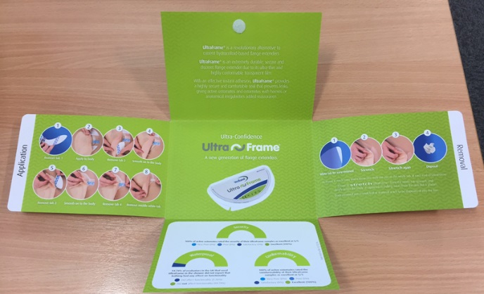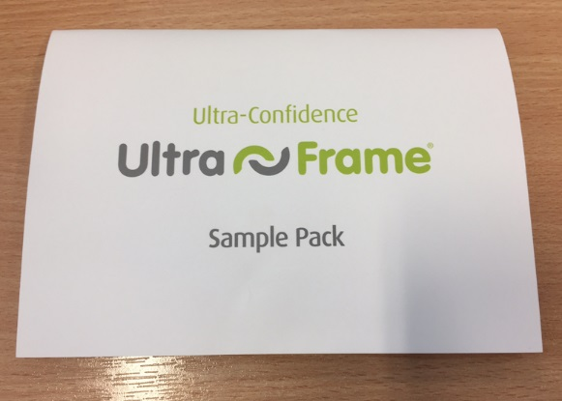

UltraFrame product – Please supply and fill locally.

